CLIMATE COLLABORATIVE
IMPLEMENTATION WORKPLAN
JUNE 2025
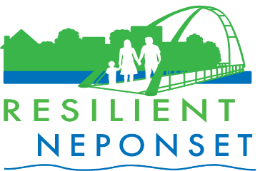
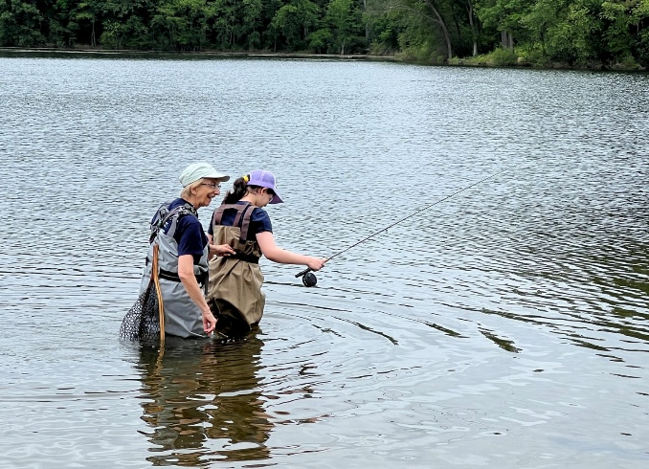
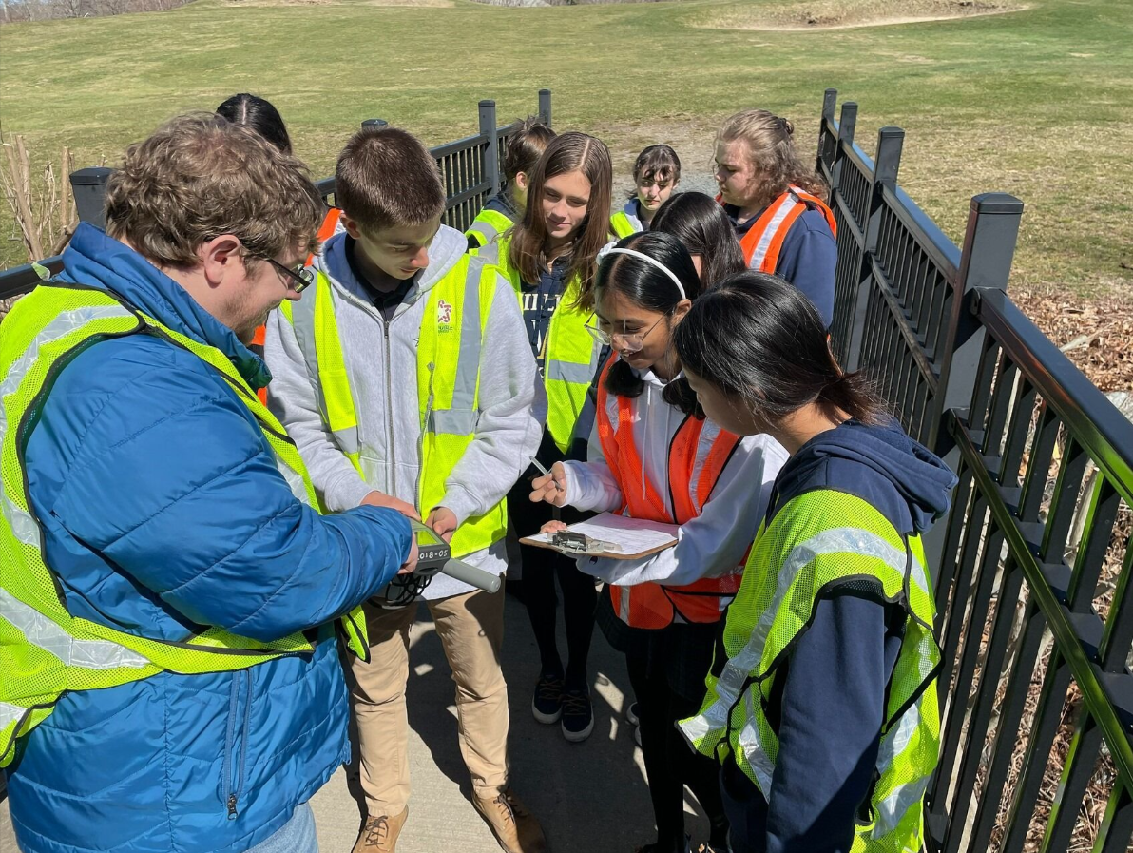
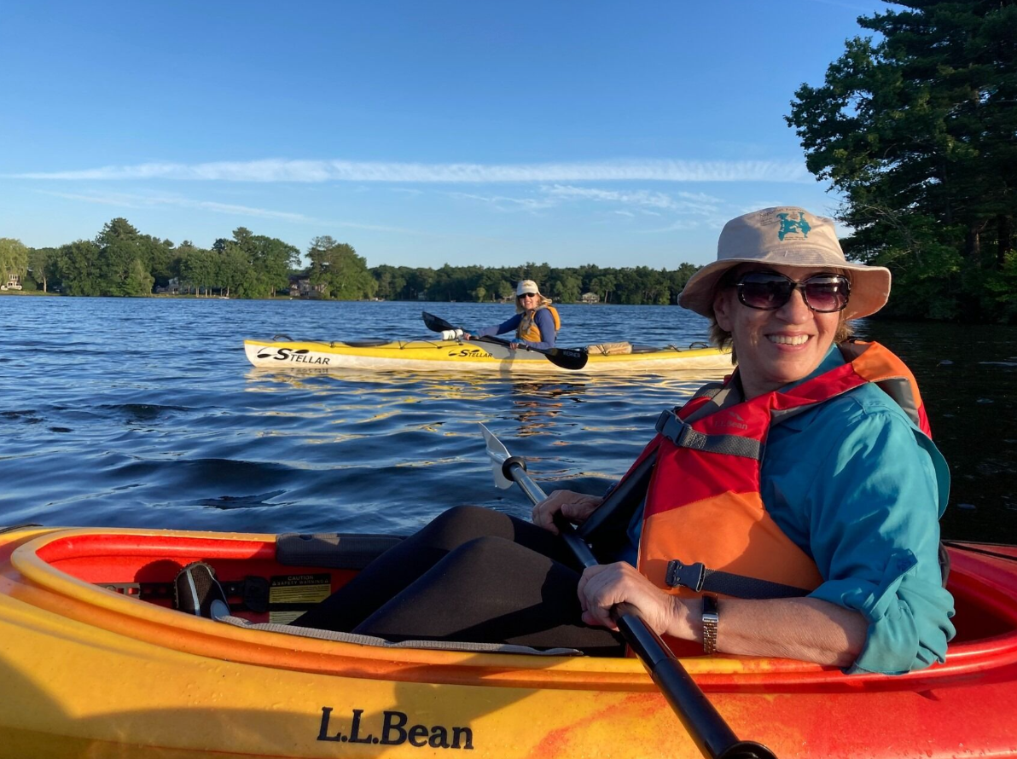
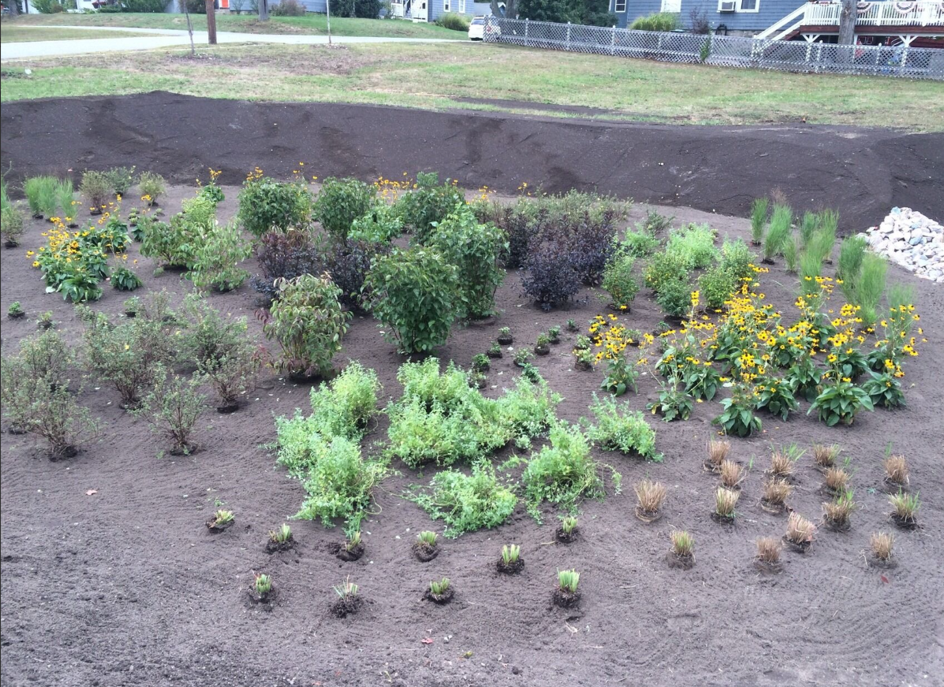

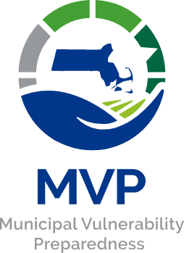
This project is supported and funded by the Executive Office of Energy and Environmental Affairs (EEA)’s Municipal Vulnerability Preparedness (MVP) Program.

Project Team
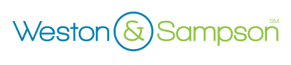
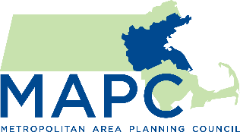
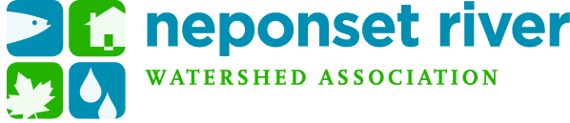
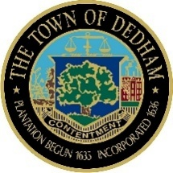

ACKNOWLEDGEMENTS
We would like to extend our sincere thanks to the Steering Committee and partner communities:

- Town of Dedham, as fiscal agent
- City of Boston
- Boston Water & Sewer Commission
- Town of Canton
- Town of Foxborough
- Town of Medfield
- Town of Milton
- Town of Norwood
- City of Quincy
- Town of Sharon
- Town of Stoughton
- Town of Walpole
- Town of Westwood

Cover photo credits NepRWA

TABLE OF CONTENTS
I. INTRODUCTION 1
About the Resilient Neponset Climate Collaborative 1
The Collaborative’s Vision and Framework 1
Overview of the Collaborative’s Implementation Workplan 1
II. PRIORITY IMPLEMENTATION ACTIONS & ROADMAPS 5
Infrastructure Improvements 6
Natural Resources, Ecological Restoration and Open Space Preservation 11
Policy and Planning 15
III. OUTREACH & ENGAGEMENT PLAN 22
Key Next Steps for Implementation of the Workplan 22
Coordination & Facilitation of the Collaborative 23
Community Outreach & Engagement 23
Implementation Next Steps 25
The Next Phase 25
Draft Statement of Mutual Agreement and Signatories of The Neponset River Watershed Climate Resilience Collaborative 26
APPENDIX A 27
Overview of the Project 27
What is The Resilient Neponset Climate Collaborative? 28
Why create the Collaborative? 28
Planning process and engagement activities accomplished to form the Collaborative 29
About the Collaborative’s Climate Resilience Framework and workplan Development 29
Summary of Processes in Phase 1 29
Process of Developing Implementation Workplan in Phase 2 30

INTRODUCTION

ABOUT THE RESILIENT NEPONSET CLIMATE COLLABORATIVE
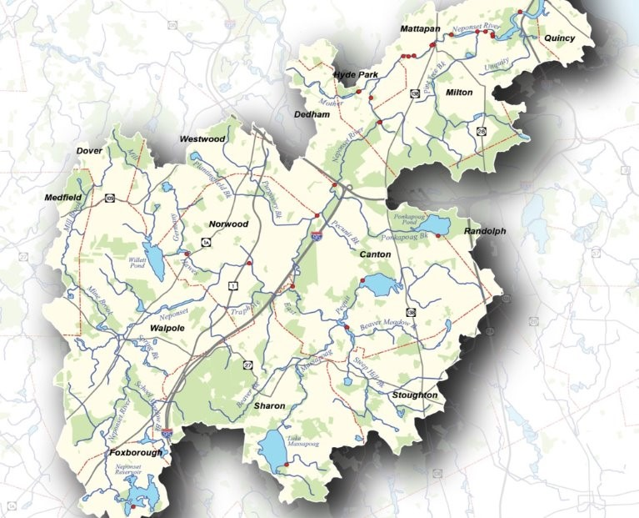
The Resilient Neponset Climate Collaborative (“the Collaborative”) comprises a group of municipalities in the Neponset River watershed, working together through best practices and shared experiences to strengthen the region’s climate resilience. Since 2022, the Collaborative has served as a convening space for municipalities to coordinate planning and implementation solutions that not only prepare but also protect them from anticipated climate change impacts such as extreme storm events, flooding, extreme heat, drought, and wildfires.
Map of the Neponset River watershed

THE COLLABORATIVE’S VISION AND FRAMEWORK:
- Fostering partnerships and collaborations to advance climate resilience planning and implementation efforts in the watershed,
- Determining collective goals and priority actions (short- and long-term) to be implemented across communities, particularly through the lens of equity to ensure just outcomes for those disproportionately impacted by climate change in the region,
- Identifying and pursuing technical assistance and funding opportunities to support watershed-scale climate resilience projects (as well as local resilience projects with regional benefits), and
- Supporting implementation of projects throughout the region to advance climate adaptation.
See Appendix A for more information about the development process and activities accomplished to date to establish the Resilient Neponset Climate Collaborative.

OVERVIEW OF THE COLLABORATIVE’S IMPLEMENTATION WORKPLAN
Together, with support from the Neponset River Watershed Association (NepRWA) and the Metropolitan Area Planning Council (MAPC), members of the Collaborative have come together and developed an implementation workplan – a guiding document to inform the Collaborative’s coordinated efforts to collectively advance climate adaptation and resilience solutions in the region. This workplan not only reflects the shared goals and priorities among municipalities of the Collaborative but also lays out in detail the three (3) strategic focus areas and 9 priority implementation actions for the next three to five years.
The three strategic focus areas are:
- Infrastructure Improvements – Implementation actions for this focus area explore opportunities to enhance the adaptability of the region’s critical built assets and systems including roads, bridges, utilities, and municipal facilities/buildings. Examples of infrastructure improvements include retrofitting and upgrading existing structures to better withstand more frequent and intense climate hazards and ensuring that future infrastructure is designed and constructed with the latest projected climate data incorporated.
- Natural Resources, Ecological Restoration and Open Space Preservation – Implementation actions in this focus area aim to protect and restore vital environmental resources and systems such as wetlands, forests, and rivers that can naturally provide enhanced climate resilience such as flood control, heat mitigation, carbon sequestration, and habitat preservation. It also includes the preservation of open space to maintain biodiversity, enhance ecosystem services, etc. Most importantly, protecting and preserving these critical natural assets will have significant impacts and benefits to public health and social well-being.
- Policy and Planning – Implementation actions in this focus area examine opportunities for developing and implementing frameworks, regulations, and strategies that strengthen climate and community resilience efforts across the watershed region.
For each of the strategic focus areas described above, the Collaborative developed 9 priority implementation actions with detailed “roadmaps” to outline the Collaborative’s work for the next three to five years. Each roadmap details recommendations including implementation steps, key stakeholders and partners (municipal departments/staff as well as community partners), and examples of technical assistance and/or funding resources. These implementation roadmaps are designed in ways that encourage cooperation among municipalities in the Collaborative to ensure efficient, cost-effective shared resources and services being developed (where appropriate) as well as larger-scale impacts/benefits to the watershed region, while still enabling tailored approaches for individual municipalities to meet their local community needs and priorities.
CENTERING EQUITY IN THE WORKPLAN
Historical development patterns rooted in systemic injustices such as racism have led to the existence of some communities primarily occupied by people of color, contributing to environmental and social inequalities. These communities often face limited green spaces, high pollution, and few recreational opportunities, making them particularly vulnerable to climate impacts like heatwaves, droughts, and floods. Hard surfaces such as pavement and buildings in these areas worsen stormwater runoff, elevate local temperatures, and exacerbate the urban heat island effect, while a lack of shade and parks further compounds these issues. This workplan aims to include actions that will integrate the voices of communities that have been historically excluded from planning efforts to ensure equitable resilience and drive meaningful, positive changes.
The Resilient Neponset Climate Collaborative strives to engrain environmental justice and climate equity as essential principles in regional planning efforts, ensuring that the most vulnerable populations are prioritized. This approach helps create a community that values diversity and addresses the full scale of climate change’s impact on all residents. This workplan focuses on preventing any group from being disproportionately affected by climate change and ensuring that the benefits of climate action are equitably distributed. Extensive community engagement, including translating materials, and collaborating with local community-based organizations (CBOs), was highlighted as integral parts of the implementation roadmaps to gather input, feedback and ensure that the plan reflects the needs of vulnerable residents. This inclusive process supports a climate equity approach that actively works toward a more just and resilient future for all. This is why ‘equity considerations were a primary evaluation criterion for priority actions to be implemented in the immediate future.

Furthermore, these implementation roadmaps prioritize equity throughout the planning and decision-making processes. This is critical because equity in planning recognizes that historical and systemic disadvantages have disproportionately impacted marginalized communities, leading to unequal access to resources and opportunities. Inclusive processes ensure that planning decisions don't perpetuate these inequities by considering the unique needs and vulnerabilities of residents. These roadmaps also include considerations of key co-benefits (such as improved public health or ecosystem services) and metrics for tracking progress of each priority action, ensuring that the Collaborative’s resilience goals are met effectively, efficiently and consistently.
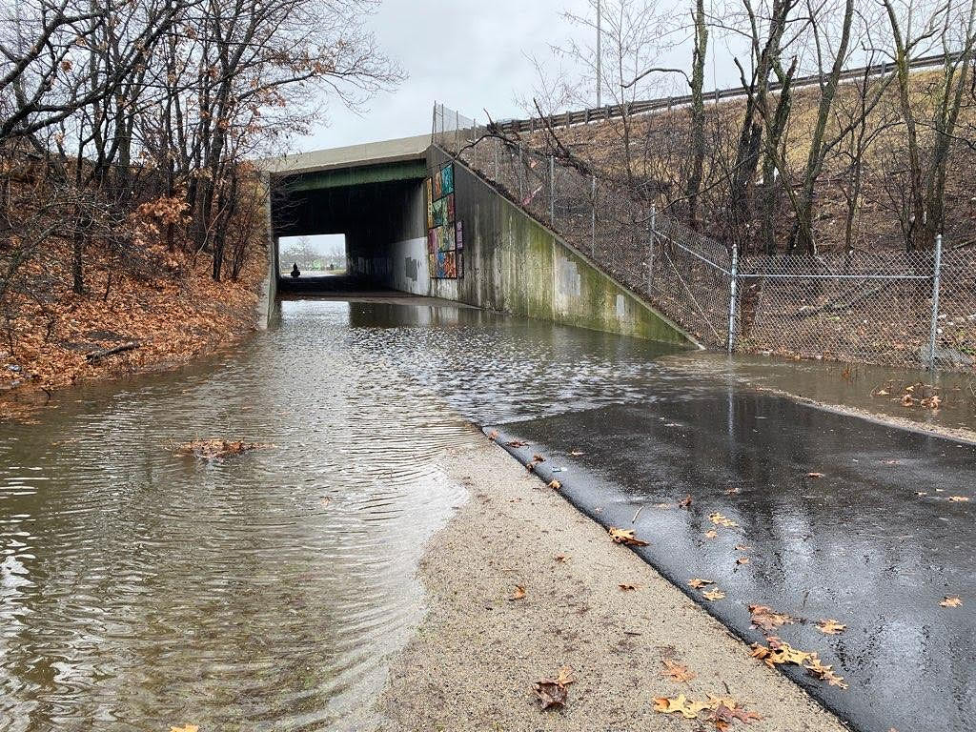
A photo depicting a flooded Neponset Greenway Trail (Photo credit: Lee Toma)

Implementation Roadmap Terms and Definitions:
Recommended Implementation Lead and Support | Implementation Lead: Municipal department(s) that will lead the implementation process.  Implementation Support: Municipal department(s) that will have relevant roles in supporting the implementation process (e.g., participating in working sessions, identifying components of the planning or permitting processes particular to their Boards and Commissions).
Key Implementation Next Steps | Outline some of the key actions (e.g., creating the necessary resources, seeking technical assistance, coordination with community partners, etc.) to achieve the desired outcomes.
Implementation Partners | External stakeholders (state agencies, community organizations, etc.) that should participate and/or be coordinated throughout the implementation process.
Potential Co-benefits | Any additional benefits that may result from the implementation of this action are beyond the direct outcomes expected or anticipated. For example: a direct outcome of incorporating more green infrastructure may be to reduce flooding (from run-off) in the community; some co-benefits of this action may be improving public health through improving air quality (due to potentially more green spaces), increasing social resilience, reducing pollutants in water and soil, etc.
Improving Equity | Key considerations and measures to be emphasized and incorporated in the implementation process to ensure an equitable outcome of the action.  The term ‘equity’ refers to fairness and justice and is distinguished from ‘equality’; whereas equality means  providing the same to all, equity means recognizing that we do not all start from the same place and must acknowledge and adjust imbalances. The process is ongoing, requiring us to identify and overcome intentional and unintentional barriers arising from bias or systemic structures.
Potential Funding Sources | Potential funding sources for planning and implementation, i.e., private and public grant opportunities
Measures of Success | Indicators to evaluate the effectiveness and impact of the action once implemented.

PRIORITY IMPLEMENTATION ACTIONS & ROADMAPS
The Collaborative identified the following priority implementation actions for the next three to five years:
Strategic Focus Areas | Priority Implementation Actions
Infrastructure Improvements | - Assess/upgrade (aging) municipal infrastructure (including dams, culverts, stormwater, water/wastewater treatment plants, pump stations, etc.) to handle more extreme storm events (current 500-year or greater) such as intense rainstorms, snowstorms and flood events. and other impacts of climate change.  - Analyze future threats to critical infrastructure, facilities and residential areas based on projections of sea level rise and intense storms.  - Perform vulnerability study on transportation, bridges, and culverts affected, or potentially affected, by future flooding, including potential evacuation routes
Natural Resources, Ecological Restoration and Open Space | - Creation of pocket parks and implementation of street-to-park conversions to enhance local cooling. Integrate opportunities to add new green space into street improvement projects. Provide spray parks in neighborhoods currently in "hot spot" areas or lacking resources (such as cooling centers, etc.)  - Protect and promote the preservation and creation of wetlands, including restoration of filled and disturbed and degraded wetlands and floodplain areas.
Policy and Planning | - Minimize impervious surfaces through revising relevant bylaws, zoning, and parking requirements. Require new development to incorporate a certain percentage of pervious area.  - Conduct a bylaw review across the region to identify regulations that address regional vulnerabilities and priorities and support towns in implementation of regulatory updates.  - Incorporate green infrastructure in all new development and redevelopment projects. Create educational programs to promote green infrastructure techniques in landscaping practice.  - Require low impact development and water conservation techniques in new development and redevelopment to reduce water usage and add connections to the surrounding open space network.

INFRASTRUCTURE IMPROVEMENTS

Priority Action 1: Assess/upgrade (aging) municipal infrastructure (including culverts, stormwater, water/wastewater treatment plants, pump stations, dams/dam removal) to handle more extreme storm events (current 500-year or greater) such as intense rainstorms, snowstorms and flood events, and other impacts of climate change.
Description: Modernized municipal infrastructure and systems can better manage increased stormwater volume and reduce the risk of failures during extreme weather events (heat and precipitation), thereby protecting communities and ecosystems. Investing in these upgrades not only mitigates potential property damage and economic loss but also improves overall public safety. Additionally, incorporating innovative design and technology can promote sustainable practices and long-term viability in the face of changing climate conditions.
Recommended Implementation Lead and Support | - Public Works  - Engineering  - Facilities  - Planning
Key Implementation Next Steps | - Conduct a municipal infrastructure assessment (or an updated assessment) to identify systems that are most vulnerable to climate impacts.  - Prioritize: those systems with the highest risk of failure; impacts to critical infrastructure and community resources; and systems located in areas of identified priority populations.  - Educate the community about critical infrastructure. Solicit input and feedback from the community to ground-truth the issues and needs for improvements.  - Identify one or two top priority projects to be implemented in the next 3-5 years.  - Create a budget and cost justification rubric that is built on information about risk avoidance tradeoffs between different designs and their risk susceptibility.  - Incorporate necessary sustainable design improvements and climate resilience measures into the implementation & construction plans based on climate change projections and available flood models. (Tie to the flood model's prioritization of critical infrastructure)  - Align project design standards with future climate data projections. Use the standards set by the Office of Climate Science to set a range of design goals.  - Set evaluation and decision-making criteria. Consider the 4-Tier system.  - Advocacy for funding of critical infrastructure and funding to modernize, upgrade and maintain systems
Implementation Partners | - United States Environmental Protection Agency (US EPA Region 1)  - Massachusetts Department of Transportation  - Massachusetts Department of Environmental Protection  - Massachusetts Department of Conservation and Recreation (lower basin)  - Massachusetts Water Resources Authority  - Neponset River Watershed Association  - Metropolitan Area Planning Council  - Public -Private Partnerships  - Private Organizations, NGOs, CBOs – The Trustees, Friends of Blue Hills, etc.
Potential Co-benefits | - Reduced long-term costs to infrastructure operations and maintenance; updated infrastructure decreases the associated costs of chronic repair and improvements.  - Ensure reliability and continuity of operations for local businesses and employers  - Improve public safety  - Protect public health?  - Reduce economic impact to residents and businesses?  - Better informed community  - Change in risk factors will lead to controlled insurance rates
Improving Equity | - Prioritization of infrastructure sites in priority population areas  - Protect and maintain essential services relied on by priority populations  - Proactive engagement of communities, especially identified priority populations, in the planning and assessment as well as during implementation
Potential Funding Sources | - Executive Office of Energy and Environmental Affairs (EEA): Municipal Vulnerability Preparedness (MVP) Action grants; Office of Dam Safety’s Dam and Seawall Repair or Removal Fund  - Massachusetts Division of Ecological Restoration (DER) culvert replacement grants and dam removal program  - Massachusetts Department of Environmental Protection (MassDEP), State Revolving Fund for wastewater or water supply upgrades
Measures of Success | - Municipality has the latest information regarding risks and vulnerabilities of their existing infrastructure and systems  - Updated/improved infrastructure sites can better withstand more frequent and intense extreme weather events (e.g., continued operations, access, and services)  - Decrease in the recorded number or severity of incidents relating to aged, outdated infrastructure.  - Established set of standards or guidelines for sustainable and resilient infrastructure design  - Integration of social and environmental goals into infrastructure design  - Municipality has completed a capacity assessment for new construction
Priority Action 2: Analyze future threats to critical infrastructure, facilities and residential areas based on projections of sea level rise and intense storms.
Description: Proactively identify vulnerable areas and prioritize necessary adaptations, ensuring public safety and resilience. By understanding potential impacts, decision-makers can allocate resources efficiently and implement protective measures before disasters occur. Additionally, such analyses foster informed community engagement and support for sustainable development practices, ultimately enhancing long-term resilience to climate change.
Recommended Implementation Lead and Support | - Public Works  - Engineering  - Planning  - Facilities
Key Implementation Next Steps | - Create a community-wide inventory of critical infrastructure and facilities, and/or review and update the critical inventory list from the latest Hazard Mitigation Plan (HMP).  - Analyze sites based on ‘Risk-based adaptation’ by considering the following parameters:  - Asset Data (analyzing spatial inventory and functional performance of asset)  - Impact Exposure (impact to asset under multiple climate scenarios and time frames)  - Asset vulnerability (Condition and functionality)  - Asset Criticality (Importance to system)  - Asset prioritization  - Cost-Benefit Analysis
Implementation Partners | - United States Environmental Protection Agency (Region 1)  - Massachusetts Department of Transportation  - Massachusetts Department of Environmental Protection  - Massachusetts Water Resources Authority (lower basin)  - Division of Capital Asset Management and Maintenance  - Metropolitan Area Planning Council  - Neponset River Watershed Association
Potential Co-benefits | - Better understanding of how to improve overall community resilience and preparedness for future climate impacts.
Improving Equity | - Proactive engagement of communities, especially identified priority populations, in the planning and assessment as well as during implementation
Potential Funding Sources | - Executive Office of Energy and Environmental Affairs (EEA): Municipal Vulnerability Preparedness (MVP) Action grants  - Metropolitan Area Planning Council (MAPC) District Local Technical Assistance/Technical Assistance Program (DLTA/TAP)
Measures of Success | - An inventory of up-to-date critical infrastructure for the development and implementation of adaptation strategies.

Priority Action 3: Perform vulnerability study on transportation, bridges, and culverts affected, or potentially affected, by future flooding, including potential evacuation routes.
Description: Identify vulnerabilities in infrastructure that may fail during extreme weather events, enabling targeted improvements to enhance resilience. By understanding potential impacts, municipalities can develop safer evacuation routes and ensure that critical transportation links remain operational during floods. Additionally, this helps allocate resources effectively, ultimately protecting public safety and minimizing economic disruption. Overall, vulnerability studies play a vital role in adapting transportation networks to meet the challenges posed by climate change.
Recommended Implementation Lead and Support | - Engineering  - Public Works  - Transportation  - Facilities
Key Implementation Next Steps | - Identify infrastructure sites which have been affected or will potentially be affected by flooding and storms [‘network failure sites’] through inventory analysis.  - Scope and acquire engineering services to conduct feasibility study  - Consider multi-municipality partnerships to expand the scope and area for the feasibility study
Implementation Partners | - United States Environmental Protection Agency (Region 1)  - Massachusetts Department of Transportation  - Central Transportation Planning Staff (CTPS), Technical Assistance  - Metropolitan Area Planning Council  - Neponset River Watershed Association  - Private businesses
Potential Co-benefits | - Reduced risk to the surrounding natural ecosystems (e.g., wetlands, forests, farmlands, etc.)  - Reduced economic impacts from storm damage
Improving Equity | - Prioritize considerations of climate impacts on the identified priority populations  - Data from vulnerability studies can be used to advocate for policies that prioritize equity in infrastructure investment.  - Proactive engagement of communities, especially identified priority populations, in the planning and assessment as well as during implementation
Funding Sources | - Executive Office of Energy and Environmental Affairs (EEA)- Municipal Vulnerability Preparedness (MVP) Action Grant  - Metropolitan Area Planning Council (MAPC) District Local Technical Assistance/Technical Assistance Program (DLTA/TAP)  - Boston Metropolitan Planning Organization (MPO), Unified Planning Work Program (UPWP)
Measures of Success | - Understanding of the region’s transportation infrastructure, vulnerabilities and priority solutions

NATURAL RESOURCES, ECOLOGICAL RESTORATION AND OPEN SPACE PRESERVATION

Priority Action 4: Creation of pocket parks and implementation of street-to-park conversions to enhance local cooling. Integrate opportunities to add new green space into street improvement projects. Provide spray parks in neighborhoods currently in "hot spot" areas or lacking resources (such as cooling centers, etc.)
Description: Expanding green space can reduce urban heat, boost air quality and mitigate flood waters. The aim of this priority action is to increase the Neponset River Watershed region’s green cover by strategically planting (and maintaining) trees and plants in priority locations, such as neighborhoods that are susceptible to high heat. In addition to absorbing heat, pocket parks can also serve as stormwater buffers. These public spaces will be designed to accommodate additional infrastructure (for example, temporary spray units and cooling centers) to provide cooling to community members. This will build upon ongoing tree maintenance programs, while prioritizing native and climate-resilient tree species.
Recommended Implementation Lead and Support | - Parks and Recreation OR Public Works OR Engineering  - Forestry department (where applicable)  - Designated Tree Warden  - Planning  - Conservation  - Public Works  - Engineering  - Board of Health  - Board of Selectmen- Delegation (primary))  - City Council
Key Implementation Next Steps | - Conduct a community-wide assessment of available and potential sites to add new green spaces (including pocket parks or ‘parklets’, street-to-park conversions, spray parks, shade structure, etc.)  - Identify top sites for project implementation in the next 3-5 years. For site selection, consider identified “hot spot” areas (e.g., concrete-heavy parking lots, areas with lack of tree canopies, etc.), as well as flood-prone areas.  - Select native and climate resilient species for planting and maintenance.  - Evaluate capacity and feasibility of adding cooling features such as shade structures or temporary ‘spray’ infrastructure in new green spaces as well as existing public spaces such as town libraries, school fields/playgrounds.  - Conduct cost assessment and budget for selected projects.
Implementation Partners | - Mass Audubon  - Massachusetts Land Trust Coalition  - Metropolitan Area Planning Council  - Neponset River Watershed Association  - Local environmental advocacy groups and community groups  - Arbor Day Foundation  - Speak for the Trees (Boston)  - The Trustees of Reservations  - Boston Food Forest Coalition  - Landscape architects/planners
Potential Co-benefits | - Reduced air pollution.  - Increased aesthetics and walkability in public spaces  - Improved stormwater management and flood control (runoff)  - Increase in compliance with municipal regulations (e.g., stormwater regulations)  - Increase in local wildlife and biodiversity  - Reduce urban heat island impacts  - Increase in opportunities for passive recreation  - Increase in market values of homes due to better neighborhood aesthetics
Improving Equity | - Prioritize native tree planting and heat mitigation strategies in identified ‘hot spots’ (i.e., areas that experience rapid increase in the hottest temperatures)  - Prioritize installation of pocket parks/green spaces in identified densely populated areas, priority population neighborhoods and/or environmental justice communities (EJ) to ensure equitable access to benefits of cooling solutions.  - Involve community members in the planning and decision-making processes to ensure that their needs and concerns are addressed.  - Ensure educational resources and outreach are available in multiple languages  - Proactive engagement of communities, especially identified priority populations, in the planning and assessment as well as during implementation
Potential Funding Sources | - Department of Conservation and Recreation (DCR), Cool Corridors Grant Program  - Executive Office of Energy and Environmental Affairs (EEA), Municipal Vulnerability Preparedness (MVP) Action grants  - Department of Conservation and Recreation (DCR)- Land Conservation Assistance Grants  - National Fish and Wildlife Foundation  - Community Preservation Corporation (CPC) grants
Measures of Success | - An increase in percentage of green space coverage  - Increased usage of outdoor spaces (community gatherings and events, etc.). Increase in availability of sites to host outdoor meetings  - Increased availability of cooling site options (and equitable distribution of these sites across the community), and increased usage of cooling sites.

Priority Action 5: Protect and promote the preservation and creation of wetlands, including restoration of filled and disturbed and degraded wetlands and floodplain areas.
Description: Wetlands are critical environmental and economic resources; they play a crucial role in the ecological functioning of watersheds and are often productive ecosystems for agriculture and aquatic species harvesting. With more intense storm events and higher risk of flooding, this action seeks to protect and restore the quality of wetlands to protect water resources, biodiversity, and minimize pollution of waterways caused by harmful runoff. After updating wetlands ordinances and policies, municipalities can work with stakeholders on best management practices to preserve and restore wetlands.
Recommended Implementation Lead and Support | - Conservation Commission  - Parks and Recreation  - Public Works  - Engineering  - City Council or Town Council  - Select Board
Key Implementation Next Steps | - Review and update local Wetlands Protection Bylaws and regulations.  - Conduct an invasive species management assessment  - Strengthen performance standards for permitting work in wetland resource areas and the 100-foot buffer zone such as conditional requirements of hay bales, silt fencing, wetlands replication areas.  - Conduct outreach to landowners and developers on flood management through wetland restoration, wide buffer zones, and maintenance driven best management practices. Include outreach with organizations (such as garden clubs) on how to be a responsible partner in preserving waterways.
Implementation Partners | - United States Environmental Protection Agency (Region 1)  - Massachusetts Department of Transportation  - Massachusetts Department of Environmental Protection  - Massachusetts Department of Ecological Restoration  - Massachusetts Department of Conservation and Recreation (lower basin)  - Massachusetts Water Resources Authority (lower basin)  - Mass Audubon  - Metropolitan Area Planning Council  - Neponset River Watershed Association  - Tribal partners  - Local environmental advocacy groups and community groups
Potential Co-benefits | - Vegetative buffer for storms and floods  - Lowered atmospheric pollution- wetlands can absorb and sequester impressive quantities of carbon per unit area compared with other ecosystems, storing most of it in sediments rather than vegetative biomass  - Reduced potential costs of remediating contaminated public wells and groundwater sources  - Enrichment of wildlife habitat, more species diversity and overall increase in ecosystem resilience
Improving Equity | - Enhance green space and storm/flood buffers in areas with identified priority populations and/or environmental justice neighborhoods  - Ensure equitable access to open space and recreational opportunities for all identified priority populations and/or environmental justice neighborhoods  - Proactive engagement of communities, especially identified priority populations, in the planning and assessment as well as during implementation  - Develop a robust plan and include resources for education and outreach about the importance of restoring and preserving wetlands
Potential Funding Sources | - USDA Natural Resources Conservation Service (NRCS)  - Executive Office of Energy and Environmental Affairs (EEA): Municipal Vulnerability Preparedness (MVP) Action Grant  - Massachusetts Office of Coastal Zone Management  - Metropolitan Area Planning Council (MAPC) District Local Technical Assistance/Technical Assistance Program (DLTA/TAP)  - National Wildlife Federation (NWF)- Five Star Wetland and Urban Waters Restoration Grants
Measures of Success | - Local wetland bylaws are updated with climate change considerations incorporated.  - Open Space and Recreation Plan is updated with climate change considerations incorporated.  - A ‘checklist’ for best management practices for wetlands and floodplain areas.

POLICY AND PLANNING

Priority Action 6: Minimize impervious surfaces by revising relevant bylaws, zoning, and parking requirements. Require new development to incorporate a certain percentage of pervious area.
Description: Revise town bylaws and regulations to mandate the incorporation of green infrastructure and nature-based solutions to support sustainable urban development by integrating natural processes into the built environment. Include measures to reduce the percentage of impervious surfaces will help reduce stormwater runoff, mitigate flooding and improve water quality.
Recommended Implementation Lead and Support | - Planning/ Community Development  - Conservation Commission  - Planning Board  - Select Board  - Engineering Depts  - (City of Boston) Green Infrastructure Team  - Environmental Action Committee  - Climate Change Resiliency and Sustainability Planning Committee  - Climate Action Plan Committees
Key Implementation Next Steps | - Assess the current bylaws and regulations (e.g., Zoning, Floodplain and Watershed Protection Districts) and identify opportunities to update with climate change considerations and opportunities for green infrastructure incorporated.  - Zoning, Floodplain, Watershed Protection Districts, Subdivision, Stormwater  - Update design standards of Site Plan Reviews to include a threshold percentage of pervious cover in development projects where applicable.  - Incorporate Coastal Flood Zone guidance and Green Infrastructure team guidance on building roadways and rights-of-ways.  - Create Community Engagement opportunities such as: public forums, online survey, webpage on town website for information (e.g., monthly E-news with “Did You Know?” articles, etc.)
Implementation Partners | - Neponset River Watershed Association  - Metropolitan Area Planning Council  - Other municipal boards/departments involved in review/enforcement of relevant bylaws (e.g., public health)  - Neighborhood Development Corporations  - Low income and high-density housing
Potential Co-benefits | - Protect and enhance local biodiversity  - Improved stormwater management/pollutant reduction/MS4 compliance  - Drought resilience (increased infiltration)?  - Reduced strain on water resources (for drinking water and recreation)  - Reduction of property damage/insurance costs (e.g., or expanding floodplain protection)  - Increased groundwater recharge-  - City of Boston well testing for buildings on piles  - Decrease in heat island effects  - Better soil erosion control
Improving Equity | - Prioritize preservation and/or expansion of green spaces/low impact development and reduce impervious cover in areas with high concentration of priority populations/environmental justice communities.  - Proactive engagement and education of communities especially identified priority populations, in the planning and assessment as well as during implementation.
Funding Sources | - Executive Office of Energy and Environmental Affairs (EEA)  - Land Use Planning Assistance Grants  - Municipal Vulnerability Preparedness (MVP) Action grants  - Metropolitan Area Planning Council (MAPC) District Local Technical Assistance/Technical Assistance Program (DLTA/TAP)  - Community Compact Best Practices Grant (Division of Local Services)  - Community Preservation Act Grants
Measures of Success | - Updated and compliant bylaws  - Incorporation of climate resilience sections and green infrastructure requirements and standards into bylaws  - A potential ‘resilience checklist’ for developers to assess projects before submitting for major and minor site plan reviews  - More buy-in from stakeholders and political officials

Priority Action 7: Conduct a bylaw review across the region to identify regulations that address regional vulnerabilities and priorities and support towns in implementation of regulatory updates.
Description: This priority action is necessary for ensuring a comprehensive understanding of shared challenges across the Neponset River Watershed region. Using a regional lens for regulatory review allows for a more cohesive approach to tackling climate impacts, as many issues, such as flooding and heat waves, do not adhere to municipal boundaries. This process helps to align local policies with regional climate adaptation goals, enhancing the effectiveness of mitigation strategies. Supporting towns in implementing these regulatory updates fosters consistency and collaboration, strengthening overall resilience across the region.
Recommended Implementation Lead and Support | - Planning/Community Development  - Conservation  - Conservation Commission  - Planning Board  - Select Board  - Engineering  - Emergency Management  - Examples of Committees and Teams for Implementation support:  - Green Infrastructure Team (City of Boston)  - Environmental Action Committee  - Climate Change and Sustainability Planning Committee  - Climate Action Plan Committees
Key Implementation Next Steps | - Review and draft recommended changes/updates to the existing bylaw language  - Conduct stakeholder engagement (municipal staff, environmental advocacy representatives, community members, etc.) to review and discuss gaps, opportunities, and needs to update the existing bylaw language, as well as the recommended changes  - Propose and seek support from relevant municipal boards and commissions to adopt the language changes
Implementation Partners | - Massachusetts Office of Coastal Zone Management  - Massachusetts Association of Conservation Commissions  - Massachusetts Department of Environmental Protection  - Neponset River Watershed Association  - Charles River Watershed Association  - Metropolitan Area Planning Council
Potential Co-benefits | - Improve local resilience and/or enhanced regional resilience  - Commonality in regulations will streamline administrative operations and municipal processes across the region
Improving Equity  . | - Ensure that regulatory updates do not create unintended consequences and/or result in development impacts on the priority populations (and their access to available resources).  - Proactive engagement of communities, especially identified priority populations, in the planning and assessment as well as during implementation
Funding Sources | - Executive Office of Energy and Environmental Affairs (EEA): Municipal Vulnerability Preparedness (MVP) Action Grant  - Metropolitan Area Planning Council (MAPC), District Local Technical Assistance/Technical Assistance Program (DLTA/TAP)  - Community Compact Best Practices Grant (Division of Local Services)  - Community Preservation Act Grants
Measures of Success  . | - All municipalities are equipped to update and ensure compliance with regulatory updates  - All municipalities have or are in the process of incorporating elements that address climate vulnerabilities and sustainability where applicable in their bylaws and regulations

Priority Action 8: Incorporate green infrastructure in all new development and redevelopment projects. Create educational programs to promote green infrastructure techniques in landscaping practice.
Description: Incorporating green infrastructure, such as rain gardens and green roofs, in all new development projects is important for effectively managing stormwater and reducing urban heat in a changing climate. This assessment can identify specific opportunities and barriers, ensuring that sustainable practices are tailored to each site’s unique characteristics. Additionally, creating educational programs for landscape professionals and homeowners on techniques like permeable paving and native plant landscaping equips them with the skills to implement green solutions effectively. By increasing awareness and understanding of these practices, communities can better address issues like flooding and heat stress while enhancing local biodiversity.
Recommended Implementation Lead and Support | - Conservation/Conservation Commission  - Planning /Planning Board  - Support examples:  - Stormwater Committee  - Green infrastructure team
Key Implementation Next Steps | - Conduct feasibility assessments and site selection for integration of green infrastructure by engaging developers, stakeholders and local communities.  - Ensure compliance with bylaws and regulations  - Develop a model for training sessions, educational workshops and resources to promote green infrastructure development.
Implementation Partners | - Massachusetts Department of Environmental Protection  - Metropolitan Area Planning Council  - Neponset River Watershed Association  - Charle River Watershed Association (bordering towns)  - PowerCorpsBOS  - Communities Responding to Extreme Weather (CREW)  - School clubs (garden clubs, etc), local nurseries
Potential Co-benefits | - Enhanced biodiversity and ecosystem resilience  - Increased community wellbeing  - Increase in economic opportunities such as employment and increase in property values.
Improving Equity | - Prioritization of sites where populations are disproportionately impacted by flooding and urban heat effects.  - Proactive engagement of communities especially identified priority populations, in the planning and assessment as well as during implementation.  - Workforce development in green infrastructure
Funding Sources | - Executive Office of Energy and Environmental Affairs (EEA): Municipal Vulnerability Preparedness (MVP) Action grants  - Office of Coastal Zone Management  - Mass Department of Environmental Protection  - Section 319 Nonpoint Source Competitive Grants  - Community Preservation Funds
Measures of Success | - Established standards and/or requirements for incorporating green infrastructure in new and future development proposals  - Municipalities have educational resources and promote the benefits of green infrastructure  - Community awareness around the benefits of green infrastructure and available technical assistance to support them with implementation  - Net reduction in impervious surface area  - Increase number of implemented projects with nature-based solutions incorporated

Priority Action 9: Require low impact development (LID) and water conservation techniques in new development and redevelopment to reduce water usage and add connections to the surrounding open space network.
Description: Requiring low impact development in new development and redevelopment projects, with connections to surrounding open space networks will reduce impervious surfaces generated through community growth. This will enhance stormwater management, improve water quality, and reduce the amount of water necessary for nonessential outdoor use.
Recommended Implementation Lead and Support | - Planning /Planning Board  - Conservation/Conservation Commission  - DPW/Engineering  - Sustainability Advisory Committee  - Board of Health  - Water Districts/Water Departments
Key Implementation Next Steps | - Evaluate existing bylaws and regulations to identify opportunities for inclusion of LID and water conservation requirements.  - Deploy a Collaborative-led educational outreach campaign on low-impact development techniques, water conservation,  - Develop model language that incorporates best practices for the inclusion of such requirements within local regulation.
Implementation Partners | - Massachusetts Department of Conservation and Recreation  - Metropolitan Area Planning Council  - Neponset River Watershed Association  - Charles River Watershed Association (bordering towns)  - Neponset Greenway Council
Potential Co-benefits | - Enhanced biodiversity and ecosystem resilience  - Increased community wellbeing  - Enhance local cooling  - Improve stormwater management  - Improve air quality  - Enhanced opportunities for recreation  - Improved public health
Improving Equity | - Proactive engagement of communities especially identified priority populations, in the planning and assessment as well as during implementation.
Funding Sources | - Executive Office of Energy and Environmental Affairs (EEA): Planning Assistance Grants  - Metropolitan Area Planning Council (MAPC), District Local Technical Assistance/Technical Assistance Program (DLTA/TAP)
Measures of Success | - Reduction in impervious surface area can be measured by a decrease in impervious surface coverage in new and redevelopment projects compared to previous baselines. This includes increased use of pervious materials and preservation of open space connected to surrounding natural areas.  - Tracked improvements in stormwater management through reduced runoff volumes and enhanced water quality indicators such as lower nutrient or sediment levels.  - Decrease in municipal water use for nonessential outdoor purposes in areas where LID practices are adopted.

OUTREACH & ENGAGEMENT PLAN

KEY NEXT STEPS FOR IMPLEMENTATION OF THE WORKPLAN
Successful implementation of this workplan relies greatly on the participation and collaboration among members of the Resilient Neponset Climate Collaborative. The following “next steps” have been identified by the Collaborative to ensure ongoing support for municipalities to participate in the Collaborative and advance the priority actions identified in this workplan.
- Prioritization of the priority implementation actions for the next 3-5 years.
It will be important and strategic for the Collaborative to assess appropriate timing and feasibility for implementing the shared priority actions identified in this workplan. Recognizing that municipal members of the Collaborative, while committed to advancing climate resilience efforts in the region, have also competing priorities locally and limited staff capacity. As such, building consensus within the Collaborative to identify how and when to implement priority actions will be key. The prioritization of these implementation actions could be determined by selecting one action from each of the strategic focus areas to pursue each year for the next 3-5 years.
It should be noted that the workplan is designed so that not all members of the Collaborative need to participate in the implementation of all priority actions listed in this workplan. It is also possible to have one or two municipalities collaborating to pilot implementation of an action and leverage their outcomes to replicate or scale up the implementation efforts for others in the Collaborative.
- Ongoing engagement with municipal leaders
While municipal staff have represented and contributed significantly to the development of this workplan, it will be equally important to present the workplan (and subsequently reporting on progress of the workplan) with municipal leadership teams (boards and commissions, etc.). These engagement opportunities will help to inform the local leadership teams of the great work their municipalities are shepherding, as well as building more support for municipal staff to participate in the Collaborative’s work.
- Annual Climate Resilience Summit and monthly coffee chats
The Collaborative will plan on hosting an annual meeting to “report out” on all the accomplishments made by the Collaborative (collectively) as well as by municipal members in their local communities. All relevant municipal departments (planning, public works, conservation, etc.) will be invited as there are currently very limited opportunities in the region for everyone who works on various facets of climate issues to convene in the same space.
In a less formal and more frequent format, the Collaborative can also host recurring ‘Coffee Chats’ to offer municipal staff a networking platform to connect, share their wins and best practices, and explore synergies and potential partnerships. These gatherings are designed to be relationship-building opportunities that strengthen collaboration and keep climate action as a primary goal within and across municipal departments.
- Progress Tracking and Best Practice Sharing
- Crosstalk and Peer Learning: Engage in an initial “sharing and learning” period during which municipalities openly share insights, approaches, and lessons learned. This crosstalk will build collective knowledge and avoid duplicative efforts.
- Developing Progress Tracking Metrics: Establish clear and measurable indicators for tracking progress on roadmap actions.
- Reporting: Share project progress summaries regularly across municipalities to maintain mutual learning and accountability.

COORDINATION & FACILITATION OF THE COLLABORATIVE
The Neponset River Watershed Association (NepRWA) will serve as the lead facilitator to support the Collaborative with operations of the Collaborative as well as the implementation of its workplan. Supporting efforts include:
- Facilitating Key Conversations and Meetings: NepRWA will help plan and facilitate annual summits, interdepartmental meetings, and cross-municipal forums, ensuring inclusive, productive, and action-oriented dialogue.
- Supporting Progress Tracking: NepRWA will assist in collecting and synthesizing updates from Collaborative members, maintaining shared metrics, and compiling progress summaries to ensure transparency and accountability.
- Developing Engagement Materials: NepRWA will lead/support the creation of shared community engagement tools, including public-facing summaries, social media content, and communications templates, which municipalities can adapt and use locally.
- Grant and Resource Support: NepRWA will provide support in identifying and pursuing grant funding opportunities, coordinating access to technical assistance (TA) resources, and helping Collaborative members connect with external partners, state agencies, and subject-matter experts as needed.
As the primary regional partner, NepRWA will provide the strategic support necessary to help Collaborative members implement the workplan effectively and equitably across the region.

COMMUNITY OUTREACH & ENGAGEMENT
- Community Awareness and Education
- The workplan will be shared with community groups through local networks. The Community Advisory Group (CAG) (to evolve and grow into the Climate Action Team), will act as an important conduit for distributing information, generating interest, and creating local conversations around the plan’s priorities.
- Efforts will be made to introduce the basics of the workplan to youth through schools, extracurricular programs, or community events.
- The final workplan will be published and maintained on the NepRWA website, ensuring that it remains accessible to the public and regularly updated with progress summaries, resources, and engagement opportunities.
- Special attention will be given to ensuring that all segments of the community—across age, language, economic and cultural backgrounds—have equitable access to information about the workplan. This may include translation of materials, use of inclusive community channels, and targeted outreach strategies.
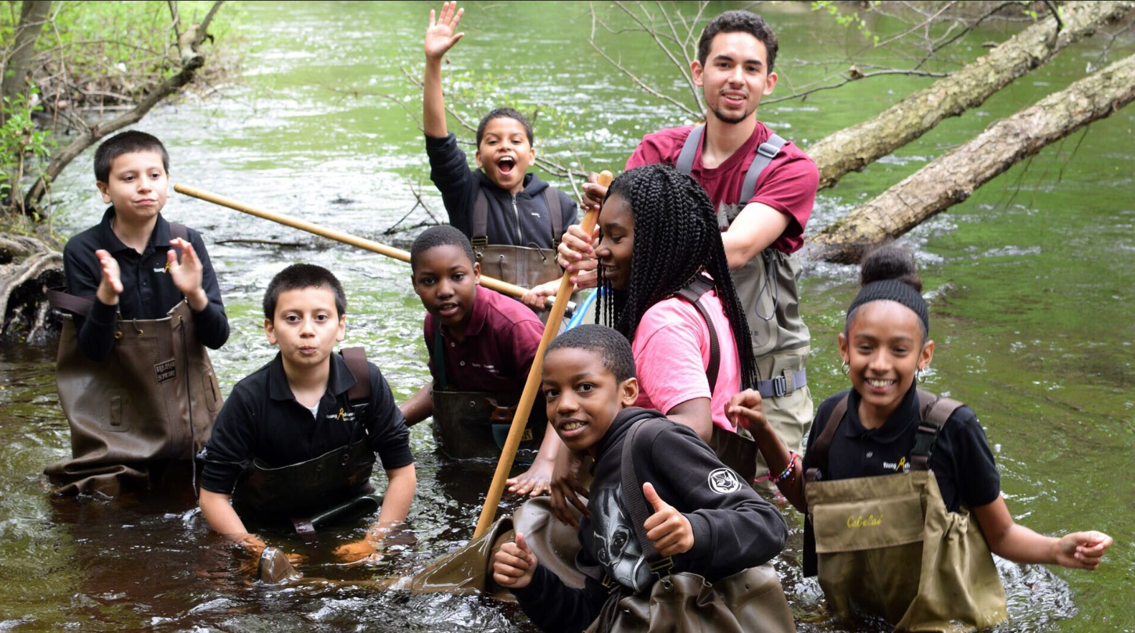
Photo Credit: NepRWA

- Consistent and Coordinated Communication
- To support effective and consistent messaging, a standard communications toolkit may be developed, including a set of social media templates, talking points, and visuals that spotlight key elements of the workplan.
- These materials will be distributed to the Communications Departments of each participating municipality, who will be responsible for tailoring and disseminating the content through their existing social media channels and community newsletters.
- This shared approach will ensure a unified voice across municipalities while allowing each to customize outreach to their local context.

- Public as Drivers of Implementation
- By sharing clear information on the implementation of the workplan and its goals, community members will be positioned to advocate for action at the municipal level. This engagement may serve as a meaningful lever to ensure community-led planning, support municipal staff and decision-makers to accomplish priority items, reinforce accountability, and align implementation timelines with public needs.

IMPLEMENTATION NEXT STEPS

The Next Phase
The top three goals for the next phase include improving regional climate resilience through:
- Using the Neponset Region Flood Model and community engagement to identify and advance nature-based implementation projects in individual cities and towns to address both heat and flooding;
- Implementing the Resilient Neponset Collaborative’s regional workplan advancing community-identified climate-resilient policy updates; and
- Improving equitable outcomes by building capacity among the public, particularly historically marginalized communities and priority populations, to meaningfully engage in the planning and implementation of climate adaptation projects in their communities across the Neponset Watershed.
In the next fiscal year (FY26), the Collaborative will aim to:
- Select and prioritize key actions for early implementation based on the roadmaps outlined in the workplan.
- Secure formal endorsement from municipal leadership to support and implement the workplan.
(Please see draft agreement letter)

DRAFT STATEMENT OF MUTUAL AGREEMENT AND SIGNATORIES OF THE NEPONSET RIVER WATERSHED CLIMATE RESILIENCE COLLABORATIVE
The Resilient Neponset Climate Collaborative (“the Collaborative”) represents a group of municipalities in the Neponset River Watershed that will work together, through best practices and shared experiences, to enhance the region’s climate resilience. Members will prioritize coordination on a watershed-scale to develop and implement climate adaptation strategies to address climate change impacts , including extreme storm events, extreme temperatures, drought and flooding due to increased frequency and volume of rainfall.
Together, participating members of this Collaborative shall:
- Foster partnerships and collaboration to advance climate resilience planning and implementation efforts in the watershed;
- Determine collective goals and priority actions (short- and long-term) to implement across communities, particularly through the lens of equity to ensure just outcomes for those most disproportionately impacted by climate change in the region;
- Identify and pursue technical assistance and funding opportunities to support watershed-scale climate resilience projects (as well as local resilience projects that will benefit the region); and
- Support implementation of projects to improve climate adaptation throughout the watershed. As a member of the Collaborative, we pledge to each other our support for the shared vision that these principles and actions represent. We commit to actively pursuing strategies that have the capacity to have the greatest collective and positive impact.
SIGNATORY OF THE NEPONSET RIVER WATERSHED CLIMATE RESILIENCE COLLABORATIVE:
As a participating member of this Collaborative, [INSERT MUNICIPALITY’S NAME] agrees to the following, to be implemented both at local and regional, watershed-scale levels:
- Develop and maintain structures for sustained regional and inter-municipal coordination to support the implementation of priority climate actions, with a focus on protecting critical infrastructure, natural resources and shared community systems identified in the workplan.
- Designate appropriate staff resources and relevant expertise to actively participate in the Collaborative, contributing to the planning, coordination, and execution of regionally aligned priority actions described in the implementation workplan.
Municipality Name
Municipal Representative of Collaborative (Name and Signature)
Signature Date

APPENDIX A

OVERVIEW OF THE PROJECT
In 2023, the Massachusetts Executive Office of Energy and Environmental Affairs (EEA) awarded the Town of Dedham, in partnership with the Boston Water and Sewer Commission, the City of Boston and the Towns of Canton, Foxborough, Medfield, Milton, Norwood, Sharon, Stoughton, and Westwood, a two-year grant through the Municipal Vulnerability Preparedness (MVP) Action Grant program. This grant supported Phase 2 of the Neponset River Watershed Regional Climate Resilience Collaborative and Flood Model (Phase 2) project, which was named “Resilient Neponset” by participating communities. The project represents an effort by the municipalities located within the Neponset River Watershed to collaborate on climate adaptation strategies to more effectively and efficiently improve climate resilience region wide.
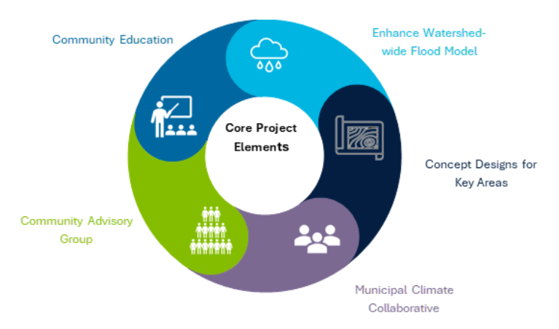
The project is multi-pronged and includes the following main goals and activities:
Graphical Representation of Core Project Elements
- Enhancement of the Neponset River Watershed-wide Flood Model
- Evaluation of additional watershed-wide flood mitigation strategies
- Establishment of the Resilient Neponset Climate Collaborative
- Organization of a Resilient Neponset Community Advisory Group
- Engagement of community members around climate change impacts and resilience-building opportunities

Through this project, the participating communities aim to establish a “Resilient Neponset Climate Collaborative” (Collaborative), through which the Neponset River Watershed Association (NepRWA) and the Metropolitan Area Planning Council (MAPC) facilitate discussion, shared learning and regional planning among municipal staff and volunteers. Importantly, participating communities have a long history of regional collaboration to accomplish shared goals more effectively through the Neponset Stormwater Partnership, the Three Rivers Interlocal Council, and the FY23 Neponset River Watershed Regional Adaptation Collaborative and Flood Model (Phase 1). In fact, it was during Phase 1 of the Resilient Neponset Project that municipal partners worked together to develop a climate resilience framework on which this workplan is based.

What is The Resilient Neponset Climate Collaborative?
The Resilient Neponset Climate Collaborative (the Collaborative) is comprised of a group of municipalities working together, through best practices and shared experiences, to enhance the region’s climate resilience.
The Collaborative serves as a convening space for municipalities to coordinate planning and implementation of climate adaptation strategies addressing climate change impacts faced by communities in the watershed, including extreme storm events, flooding, extreme heat, drought, and wildfires.

Why create the Collaborative?
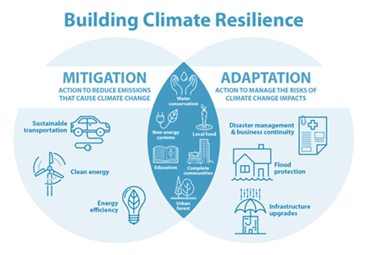
The Neponset River Watershed is home to more than 330,000 people in 14 communities in the Greater Boston region. To preserve, protect, and adapt to the changing climate, it is imperative that communities in the watershed work together and take a proactive approach to mitigating as well as preparing for anticipated climate hazards.
Graphical Representation of Differences and Overlap between Mitigation and Adaptation [Image credit: City of Calgary (CAN) Climate Change Program]
Each of the communities in the Neponset River Watershed has engaged in climate adaptation assessments and planning activities. However, no one community has the human or economic resources necessary to adapt to climate change impacts on its own. Moreover, climate change impacts do not limit themselves to municipal boundaries, and climate adaptation actions similarly should be planned and implemented regionally.
Each community, through its own planning efforts, has pinpointed key actions to enhance its climate resilience. Notably, many of these priorities align closely across communities. Given these commonalities, it makes sense for municipalities to collaborate, sharing insights and resources, to efficiently implement projects that benefit everyone.
The Collaborative and its workplan will guide climate resilience efforts, in which participating municipalities are collectively committed to advancing and implementing. The workplan provides the Collaborative with a roadmap to identify resources and opportunities for effective cooperation going forward, including robust community engagement, which is essential for the successful implementation of adaptation projects.
Although this workplan is focused on climate adaptation, mitigation efforts are also necessary to reduce the severity of climate change impacts. As the Collaborative works together on shared priorities, members may determine whether they would like to work together on other climate-related projects in addition to resilience-building.

Planning process and engagement activities accomplished to form the Collaborative
This Collaborative and its workplan are the culmination of three years of planning and engagement across the Neponset River Watershed:
- During Fiscal Year 2023, and funded through an MVP grant, partner communities identified representatives to serve on a Neponset Region Climate Collaborative Framework Development Steering Committee. The Committee was charged with meeting to discuss shared climate resilience goals and identify top priorities. The Steering Committee met twice in the Spring of 2023 to review the action items identified through individual planning processes (including, but not limited to, the development of Hazard Mitigation Plans, Open Space and Recreation Plans, and Municipal Vulnerability Preparedness Plans). The result of this effort was the Neponset River Watershed Regional Collaborative on Climate Resilience Proposed Framework.
- During Fiscal Year 2024, with the award of a second MVP grant, the Project Team met with the Select Boards of each partner town to introduce the Framework and identify representatives to participate in the Resilient Neponset Climate Collaborative Steering Committee. The Steering Committee was charged with developing a workplan and roadmap for short-, mid-, and long-term implementation of climate resilience priorities shared among participating municipalities. Facilitated by the Project Team, participants met to decide how to organize such a workplan and fill in details about which municipal departments might lead certain tasks, and what resources might be available to fund activities.
- During Fiscal Year 2025, the Steering Committee met three times to hone the workplan into an implementable roadmap for future collaboration. The Project Team took the feedback from Steering Committee members and put the workplan together in a format the Committee could review and adopt.
The result of these activities is the workplan which is described in Chapter 1.

About the Collaborative’s Climate Resilience Framework and workplan Development

Summary of Processes in PHASE 1:
Through Phase 1, the Project Team reviewed existing reports and plans previously completed by the participating communities (Boston, Canton, Dedham, Foxborough, Medfield, Milton, Norwood, Quincy, Sharon, Stoughton, Walpole, and Westwood). The goal was to find common strategies already identified by the 12 municipalities and which lend themselves to regional collaboration. The documents reviewed included Master Plans, Hazard Mitigation Plans, MVP Community Resilience Workshop Reports, Open Space and Recreation Plans, and Climate Action/Sustainability Plans. Other plans and reports prepared by a community that contained climate adaptation strategies were also reviewed when available.
Neponset River watershed communities share climate challenges and resilience opportunities because although the towns themselves are unique, the threats posed to them by climate change are not. The Project Team identified common categories of proposed interventions. One of the highest priorities across all watershed towns is mitigating flood risk, and each municipality has identified Infrastructure Improvements, Natural Resources Protection and Restoration, and Climate-Resilient Regulatory updates to accomplish that goal. Other common proposals address extreme storms, extreme heat, drought, and wildfires. Not surprisingly, many proposed strategies address multiple climate impacts (for example, reduction of impervious surfaces not only mitigates flooding but also reduces heat island effects and potentially may reduce drought impacts by increasing recharge of stormwater). In short, there are more commonalities than differences among resilience-building priorities identified by municipalities (see next section), including, but not limited to:
- Understanding climate impacts better so that adaptation strategies may be more effectively tailored to them.
- Maintaining and upgrading infrastructure, which is not only protective, but also enhances municipalities’ ability to respond to extreme events.
- Expanding public education and outreach to build capacity to engage in resilience-building planning and activities.
- Identifying and implementing nature-based strategies to address a broad range of climate impacts.
The Collaborative determined a set of evaluation criteria (see below) in accordance with identified priorities and needs in Phase 1, along with the current requirements of the watershed, to assess the implementation priorities. While a strategy may not fully meet all criteria to the same extent, this does not imply that the strategy is less critical than others.
The result of the Collaboratives activities in this Phase was a Proposed Framework intended to guide future collaborative efforts to build regional climate resilience.

Process of Developing Implementation Workplan IN Phase 2
The Resilient Neponset Climate Collaborative convened on May 30, 2024, to kick-off the development of the Collaborative’s workplan. This meeting mapped out this Collaborative’s overarching goals, activities and expectations for FY 2025 with the following immediate priorities:
- Development of a Collaborative workplan by June 2025
- Cultivation of active participation of Steering Committee in workplan development
- Determination of membership level and criteria
- Implementation of workplan over next 3-5 years
The Collaborative reviewed climate workplans across the region and country and identified some foundational themes for the workplan; collaboration, knowledge sharing, and strategic alignment across municipalities to enhance climate resilience, with a focus on long-term community engagement and formalizing commitments. The approach aims to strengthen climate resilience across municipalities by reviewing current regional projects, identifying common challenges (e.g., flooding, storm surges), and learning from existing efforts. It emphasizes facilitating networking forums for communities to share best practices in resilience-building and exploring various strategies for implementing projects, including considering environmental justice, funding, and accountability. Key municipal representatives, such as those from public health, community development, and planning committees, should be involved in developing the workplan. Ultimately, formalizing the commitment will require support from town administrations, with the Select Board playing a crucial role in endorsing the workplan.
Subsequent meetings of the Collaborative focused on categorizing implementation strategies, defining specific actions under each strategy and implementation roadmaps for each priority action.
The organization of the workplan’s strategies was based on priorities identified from the Collaborative’s Proposed Framework in Phase 1, along with immediate needs of the watershed region. Many of the strategies identified will provide valuable co-benefits that will help create greener streets, less flooding, cooler parks, a more intact ecosystem, cleaner air, and healthier places for residents and nature to exist in a changing world.
Description of Evaluation Criteria for these strategies:
The following set of high-level criteria were employed to evaluate and identify the top priority strategies, which the Collaborative will collectively pursue for the next 3-5 years.
- Centering equity – This criterion determines whether a strategy contributes to improving social equity for communities in the watershed.
- Co-benefit potential - This criterion determines whether a strategy has and/or will lead to other co-benefit(s) (such as increased public access, economic/workforce development, public health improvements, public safety, or improved biodiversity, etc.)
- Level of effort to implement (for municipal staff) - This criterion determines the level of effort that will require municipal staff’s involvement and/or capacity with its implementation.
- Cost to implement (to town, businesses, and/or community residents) - This criterion determines the potential cost(s) associated with the strategy that will be required of municipality and/or residents.
- Capitalize on local projects that are in progress or completed- This criterion determines the level of alignment with the key needs of existing projects, ensuring they address relevant gaps and enhance ongoing efforts.
- Potential for public support and community engagement –This criterion determines the potential for community engagement, ensuring they align with the expressed needs and priorities of residents through collaborative planning and feedback processes.
Using these criteria, the Steering Committee identified and prioritized 9 implementation actions categorized into 3 strategic focus areas, as included in the final Workplan.

Chang, C. M., & Hossain, A. (2024). A Climate Adaptation Asset Risk Management Approach for Resilient Roadway Infrastructure. Infrastructures, 9(12), 226. https://doi.org/10.3390/infrastructures9120226 ‌
As practicable within available resources, including grants and municipal support.

